- Overview of Inspection Information Management System (IIMS)

What is IIMS — Inspection Information Management System?
- A national digital inspection platform developed by the Food Control Administration Unit of the Ministry of Health.
- Used by authorized officers in food safety.
- Has several key domains covering the full range of food safety inspection and control activities.

Key Domains in the IIMS?
- Food Premises Registration
- Food Premises Grading
- Food Sampling
- Food Inspection
- Reports
- Import Control
- Export Controls
- Water Bottle Factory Registration
- Salt Factory Registration
- Health Claims

Key Stakeholders and Their Roles in IIMS
- Food Control Administration Unit: Develops and maintains the IIMS platform; sets national standards for digital inspection.
- Authorized Officers of Food Safety (MOH, PHI, F & DI): Primary system users responsible for conducting inspections and entering data.
- Food Laboratories: Receive digital sample requests, upload test results, and integrate findings into IIMS.

How to Log in to IIMS System of FCAU ?
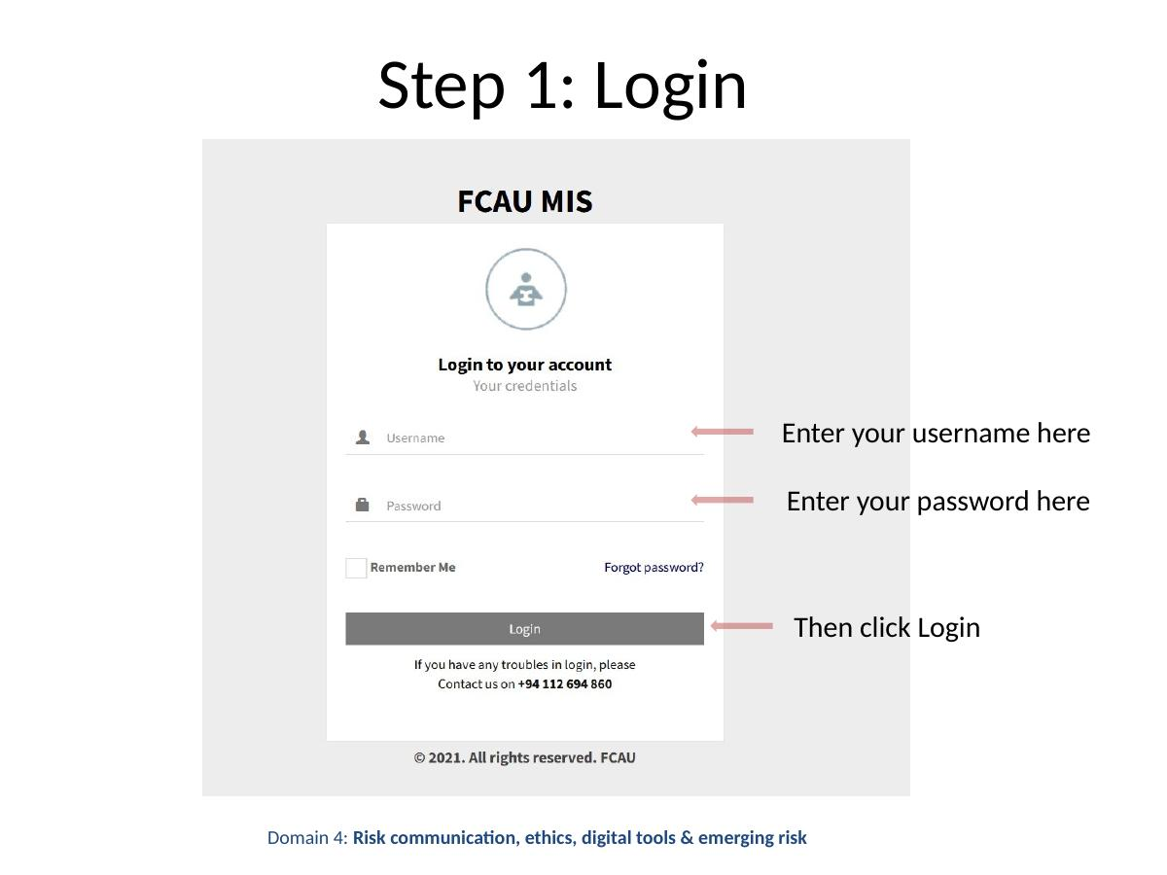

Inspection Workflow — System Overview
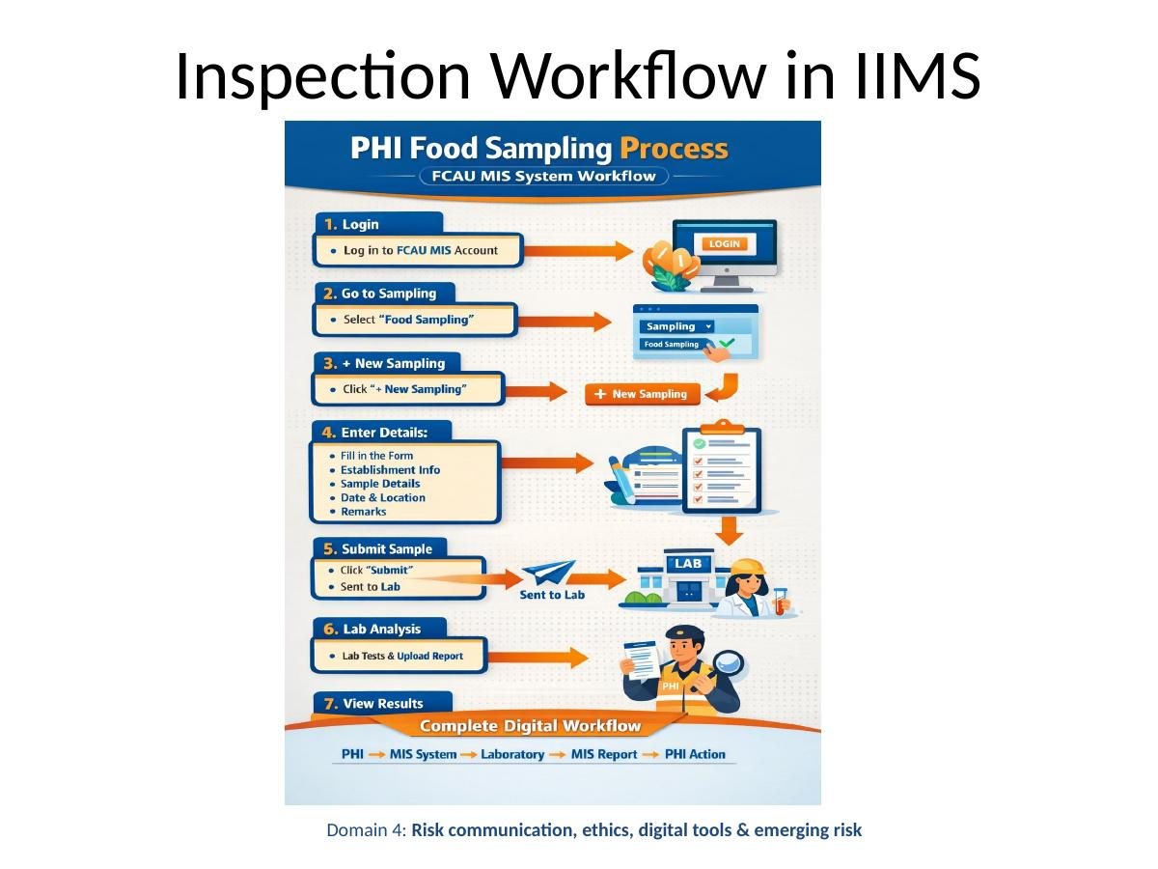
The IIMS inspection workflow guides authorized officers through a structured digital process — from logging in, selecting sampling activities, entering data, submitting samples, through to viewing lab results and downloading reports.
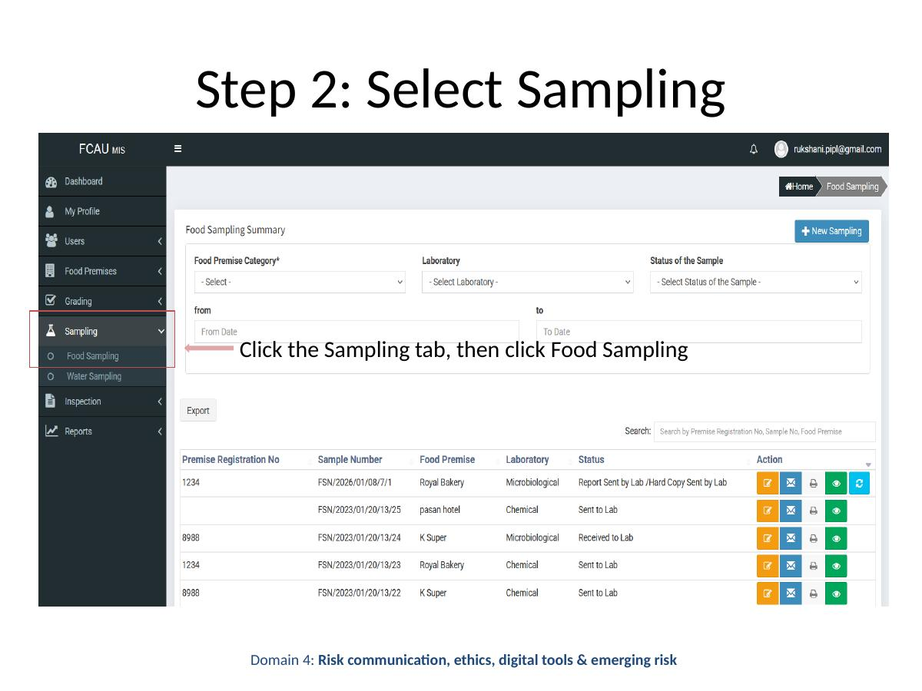

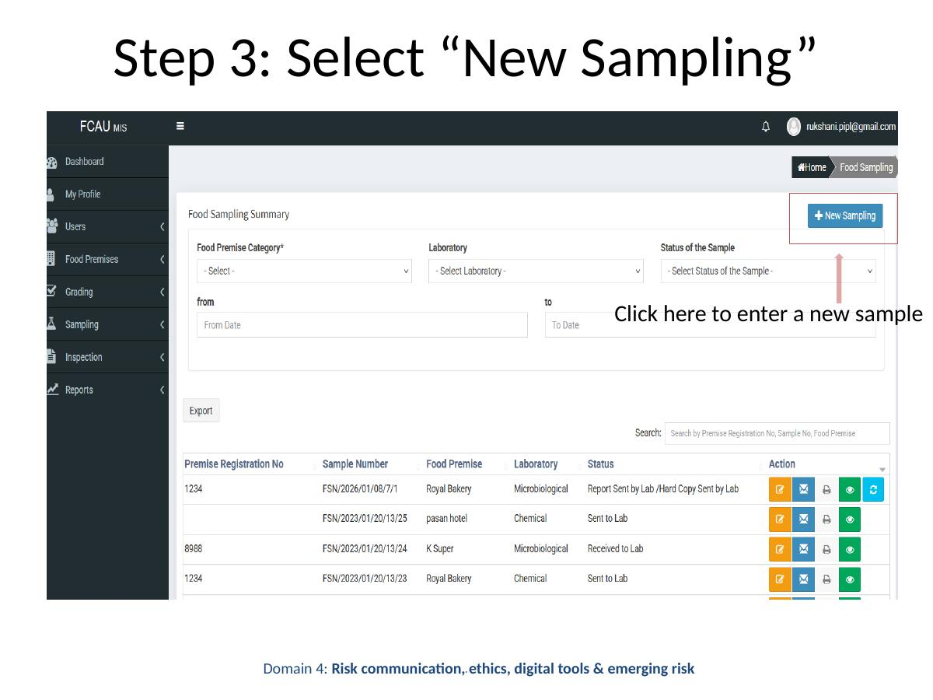

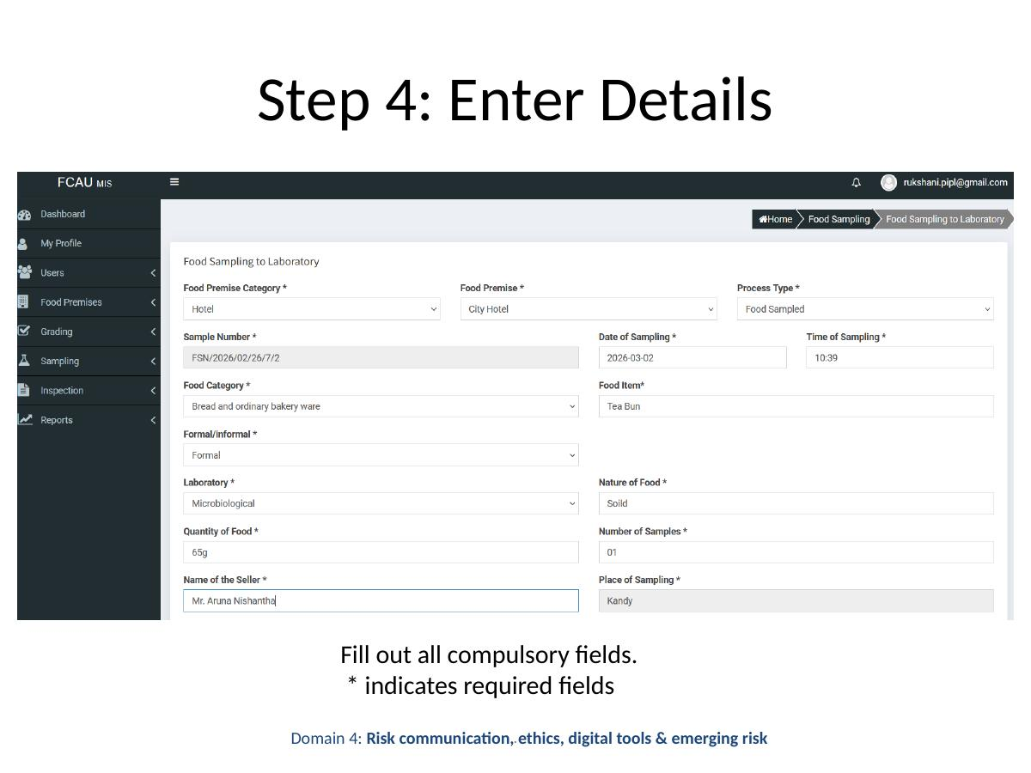

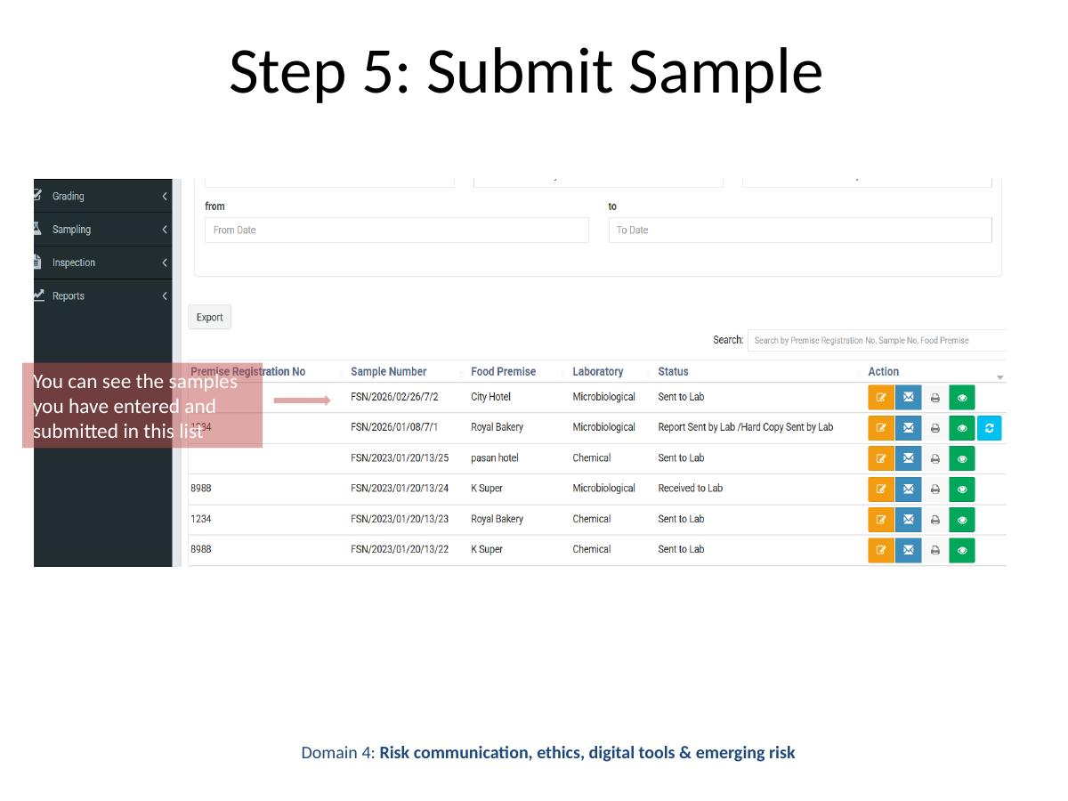

IIMS System — How to add a sample to the system?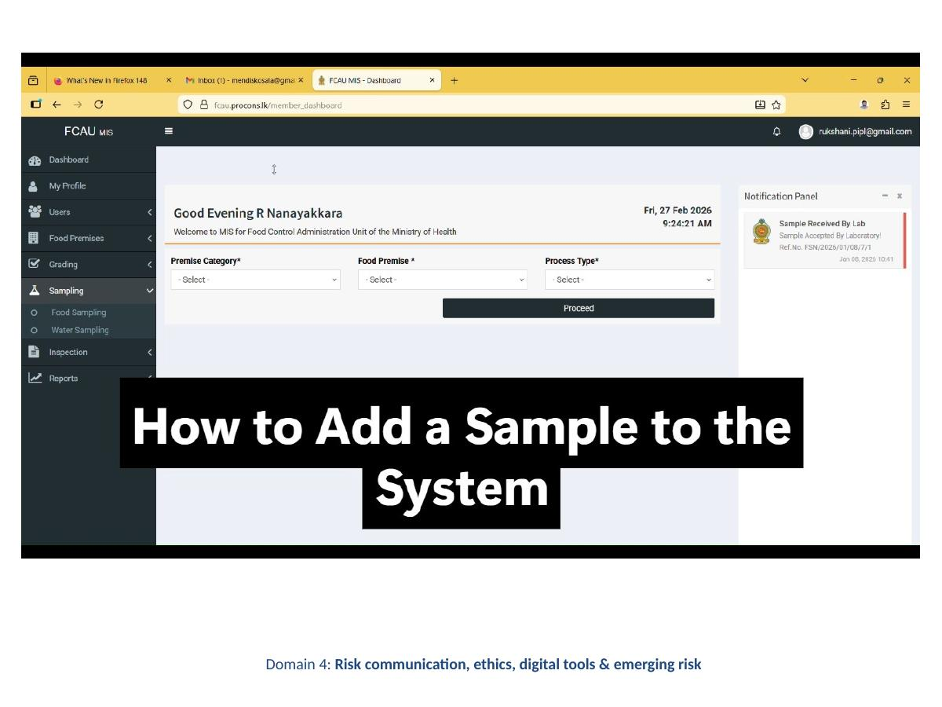
The system displays a list of all submitted samples, allowing officers to track status and manage records efficiently.
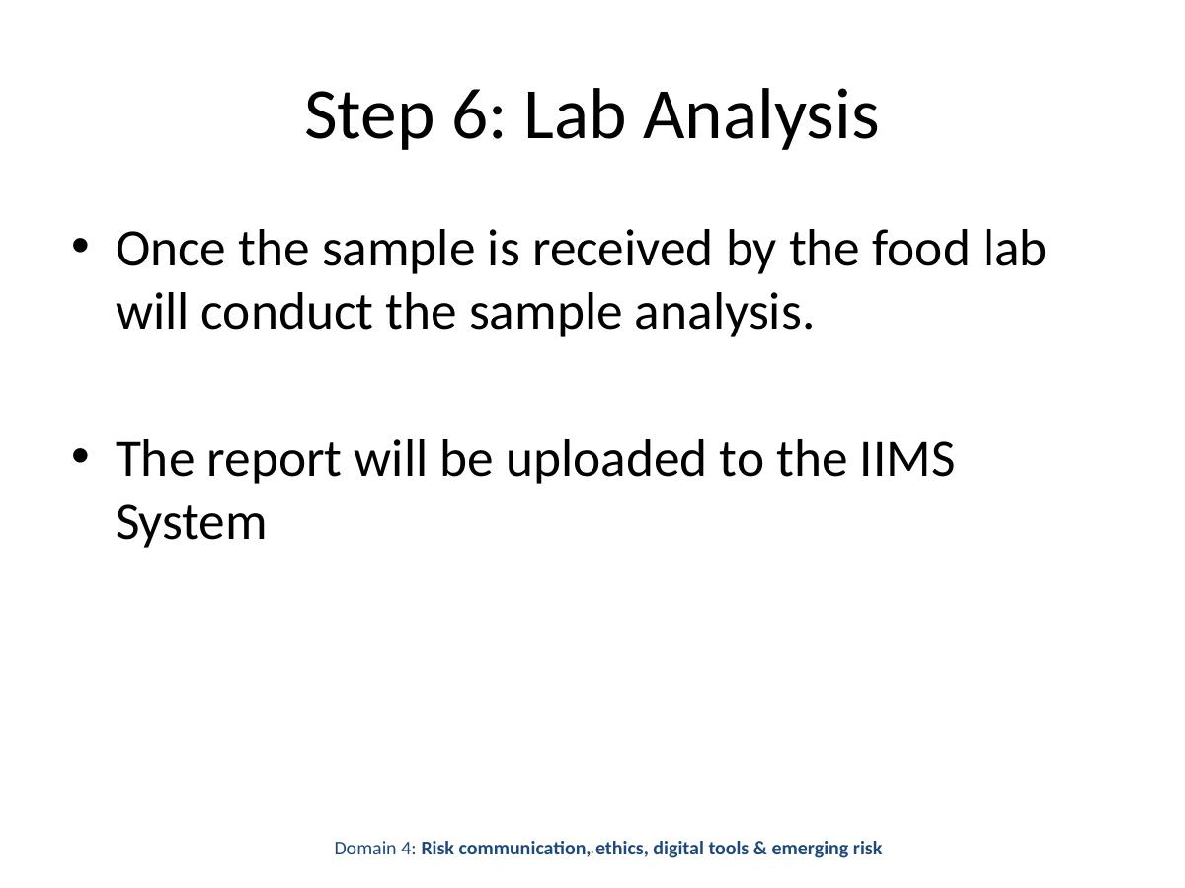

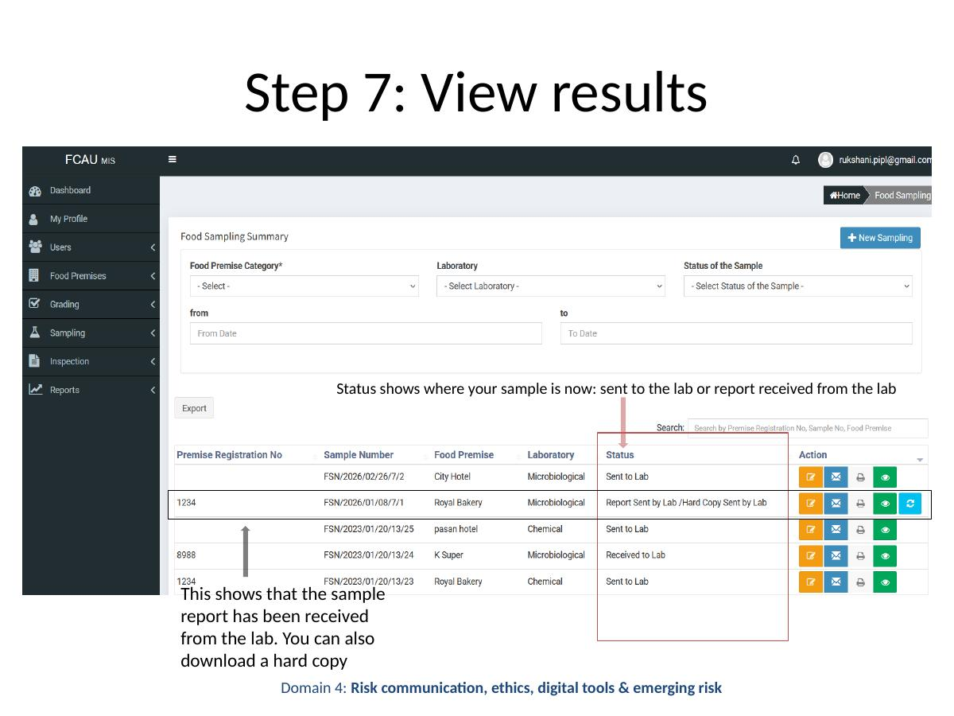

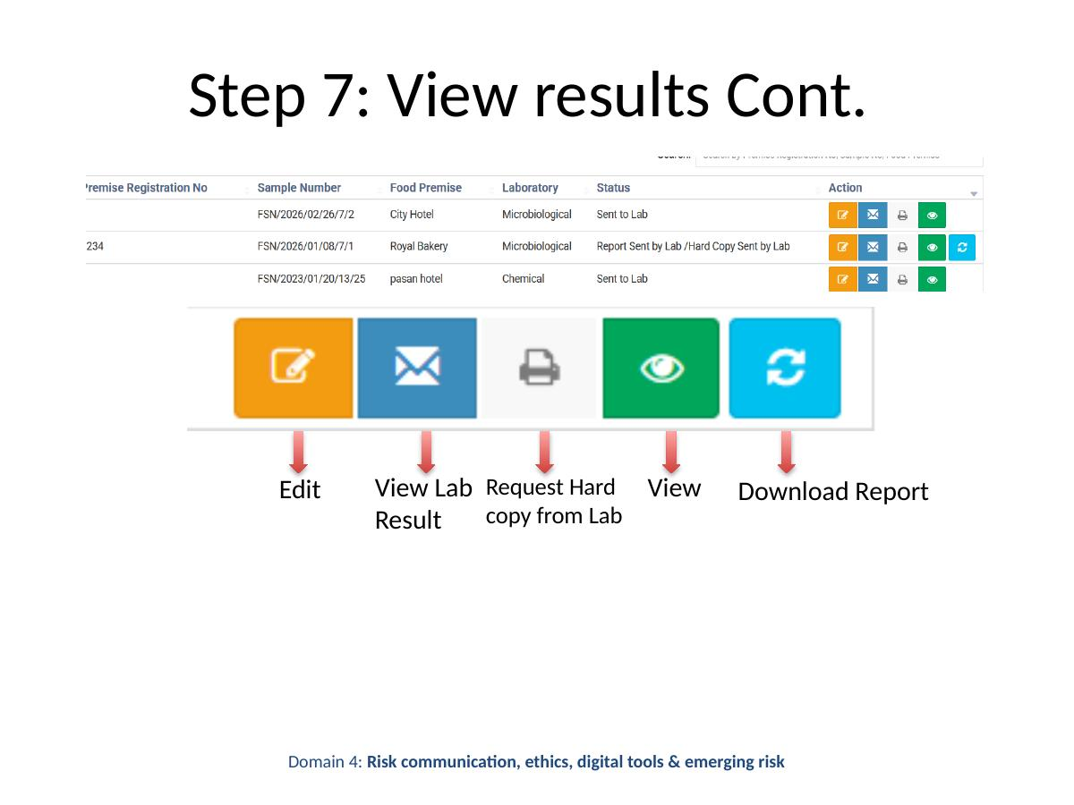
Once lab results are available in IIMS, the following actions can be performed:
- Edit — Modify sample details if required.
- View Lab Result — Review the full laboratory report online.
- Request Hard Copy from Lab — Submit a formal request for a printed copy of the report.
- View — Open the sample record for detailed viewing.
- Download Report — Save or print the report for records.

Premises Registration
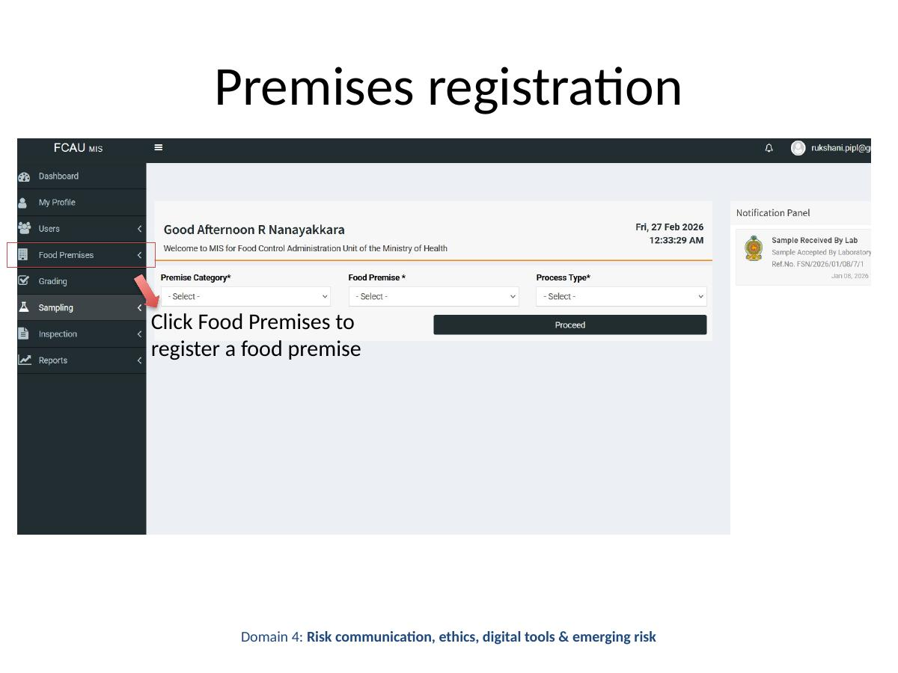
To register a food premise, click the Food Premises option in the IIMS navigation menu. This opens the premises registration module where new premises can be added to the national registry.
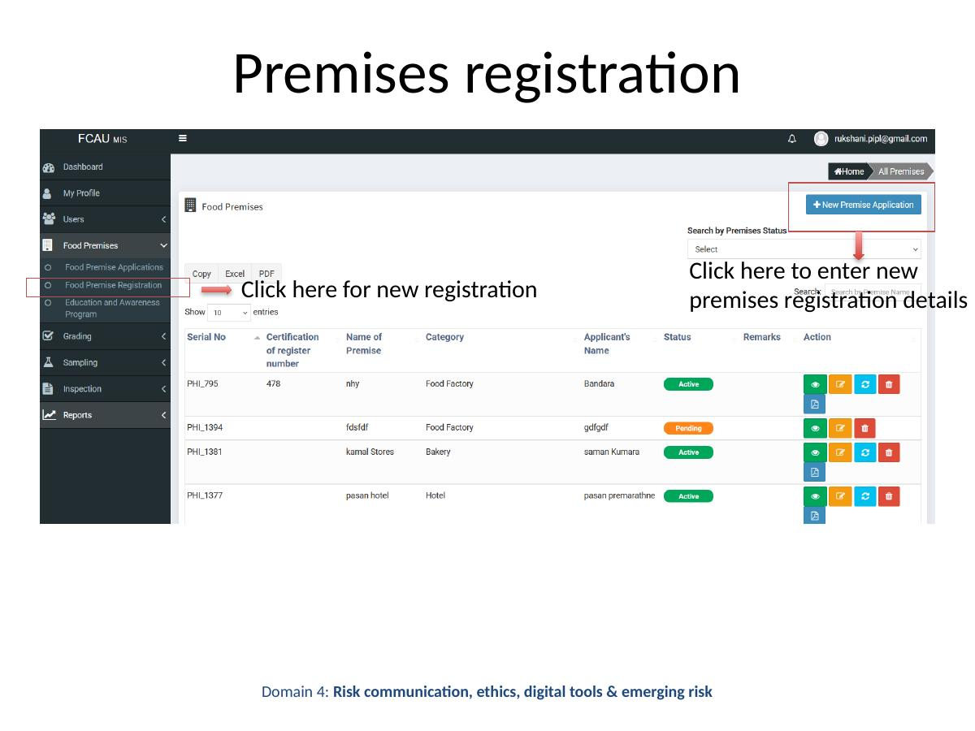
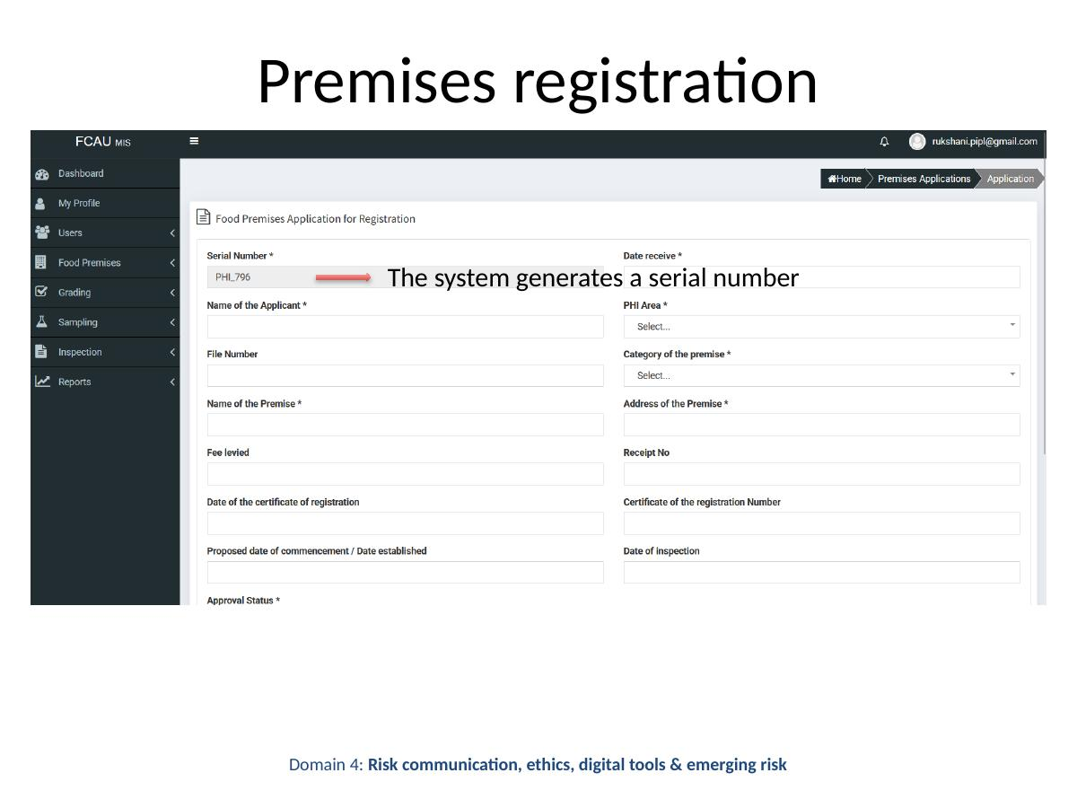
Upon successful entry and submission of premises registration details, the IIMS system automatically generates a unique serial number for the registered premises. This number serves as the official identifier for all future inspections and records related to that premises.

